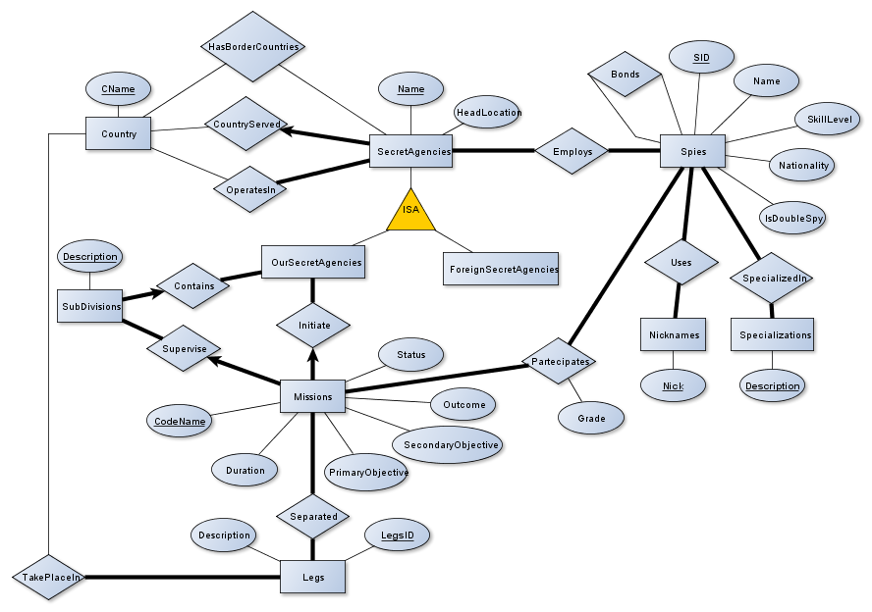

RELATIONAL SCHEMA OF SpyDB

OurSecretAgencies(Name, HeadLocation, CountryServed)

CountryServed is a Foreign Key to table Country

SubDivisions(Description, Agencies)

Agencies is a Foreign Key to table OurSecretAgencies

ForeignSecretAgencies(Name, HeadLocation, CountryServed)

CountryServed is a Foreign Key to table Country

ForeignHasBorderCountries(CName: unique, Name: unique)

CName is a Foreign Key to table Country

Name is a Foreign key to table ForeignSecretAgencies

HasBorderCountries(CName: unique, Name: unique)

CName is a Foreign Key to table Country

Name is a Foreign key to table OurSecretAgencies

ForeignOperatesIn(CName: unique, Name)

Name is a Foreign Key to table ForeignSecretAgencies

CName is a Foreign Key to table Country

OperatesIn(CName: unique, Name)

Name is a Foreign Key to table OurSecretAgencies

CName is a Foreign Key to table Country

Missions(CodeName, Duration, Status: not NULL, PrimaryObjective: not NULL, SecondaryObjective, Outcome, InitiatedBy, SupervisedBy)

InitiatedBy is a Foreign Key to table OurSecretAgencies

SupervisedBy is a Foreign Key to table SubDivisions

Separated(CodeName, LegsID)

CodeName is a Foreign Key to table Missions

LegsID is a Foreign Ket to table Legs

Legs(LegsID, Description)

TakePlaceIn(LegsID, CName: unique)

LegsID is a Foreign Key to table Legs

CName is a Foreign Ket to table Country

Spies(SID, Name, SkillLevel, Nationality: not NULL, IsDoubleSpy: not NULL)

SpecializedIn(SID, Description)

SID is a Foreign Key to table Spies

Description is a Foreign Key to table Specializations

Bonds(Spy1: unique, Spy2: unique)

Spy1 is a Foreign Key to table Spies

Spy2 is a Foreign Key to table Spies

Employs(Name, SID)

Name is a Foreign Key to table OurSecretAgencies

SID is a Foreign Key to table Spies

ForeignEmploys(Name, SID)

Name is a Foreign Key to table ForeignSecretAgencies

SID is a Foreign Key to table Spies

Uses(SID, Nick)

SID is a Foreign Key to table Spies

Nick is a Foreign Key to table Nicknames

Nicknames(Nick)

Specializations(Description)

Partecipates(SID, CodeName, Grade)

SID is a Foreign Key to table Spies

CodeName is a Foreign Key to table Missions

Country(CName)

STATEMENT

CREATE TABLE OurSecretAgencies(

Name VARCHAR(20) PRIMARY KEY,

HeadLocation VARCHAR(20),

CountryServed VARCHAR(20),

FOREIGN KEY (CountryServed) REFERENCES Country(CName)

);

CREATE TABLE SubDivisions(

Description VARCHAR(20) PRIMARY KEY,

Agencies VARCHAR(20),

FOREIGN KEY (Agencies) REFERENCES OurSecretAgencies(Name)

);

CREATE TABLE ForeignSecretAgencies(

Name VARCHAR(20) PRIMARY KEY,

HeadLocation VARCHAR(20),

CountryServed VARCHAR(20),

FOREIGN KEY (CountryServed) REFERENCES Country(CName)

);

CREATE TABLE ForeignHasBorderCountries(

Name VARCHAR(20) UNIQUE,

CName VARCHAR(20) UNIQUE,

FOREIGN KEY (Name) REFERENCES ForeignSecretAgencies(Name)

FOREIGN KEY (CName) REFERENCES Country(CName)

);

CREATE TABLE HasBorderCountries(

Name VARCHAR(20) UNIQUE,

CName VARCHAR(20) UNIQUE,

FOREIGN KEY (Name) REFERENCES OurSecretAgencies(Name),

FOREIGN KEY (CName) REFERENCES OurSecretAgencies(CName)

);

CREATE TABLE ForeignOperatesIn(

CName VARCHAR(20) UNIQUE,

Name VARCHAR(20) PRIMARY KEY,

FOREIGN KEY (Name) REFERENCES ForeignSecretAgencies(Name),

FOREIGN KEY (CName) REFERENCES Country(CName)

);

CREATE TABLE OperatesIn(

CName VARCHAR(20) UNIQUE,

Name VARCHAR(20) PRIMARY KEY,

FOREIGN KEY (Name) REFERENCES OurSecretAgencies(Name),

FOREIGN KEY (CName) REFERENCES Country(CName)

);

CREATE TABLE Missions(

CodeName VARCHAR(20) PRIMARY KEY,

Duration INT,

Status VARCHAR(20) NOT NULL,

PrimaryObjective VARCHAR(100) NOT NULL,

SecondaryObjective VARCHAR(100),

Outcome VARCHAR(100),

InitiatedBy VARCHAR(20),

SupervisedBy VARCHAR(20),

FOREIGN KEY InitiatedBy REFERENCES OurSecretAgencies(Name),

FOREIGN KEY SupervisedBy REFERENCES SubDivisions(Description)

);

CREATE TABLE Separated(

CodeName VARCHAR(20),

LegsID INT,

FOREIGN KEY (CodeName) REFERENCES Missions(CodeName)

FOREIGN KEY (LegsID) REFERENCES Legs(LegsID),

PRIMARY KEY (CodeName, LegsID)

);

CREATE TABLE Legs(

LegsID INT AUTO_INCREMENT PRIMARY KEY,

Description VARCHAR(20)

);

CREATE TABLE TakePlaceIn(

LegsID INT PRIMARY KEY,

CName VARCHAR(20) UNIQUE,

FOREIGN KEY (LegsID) REFERENCES Legs(LegsID),

FOREIGN KEY (CName) REFERENCES Country(CName)

);

CREATE TABLE Spies(

SID INT AUTOINCREMENT PRIMARY KEY,

Name VARCHAR(20),

SkillLevel INT,

Nationality VARCHAR(20) NOT NULL,

IsDoubleSpy BOOLEAN NOT NULL,

);

CREATE TABLE SpecializedIn(

SID INT,

Description VARCHAR(50),

FOREIGN KEY (SID) REFERENCES Spies(SID),

FOREIGN KEY (Description) REFERENCES Specializations(Description)

);

CREATE TABLE Bonds(

Spy1 INT UNIQUE,

Spy2 INT UNIQUE,

FOREIGN KEY (Spy1) REFERENCES Spies(SID),

FOREIGN KEY (Spy2) REFERENCES Spies(SID)

);

CREATE TABLE Employs(

Name VARCHAR(20),

SID INT,

FOREIGN KEY (Name) REFERENCES OurSecretAgencies(Name),

FOREIGN KEY (SID) REFENCES Spies(SID),

PRIMARY KEY (Name, SID)

);

CREATE TABLE ForeignEmploys(

Name VARCHAR(20),

SID INT,

FOREIGN KEY (Name) REFERENCES ForeignSecretAgencies(Name),

FOREIGN KEY (SID) REFERENCES Spies(SID),

PRIMARY KEY (Name, SID)

);

CREATE TABLE Uses(

SID INT,

Nick VARCHAR(20),

FOREIGN KEY (SID) REFERENCES Spies(SID),

FOREIGN KEY (Nick) REFERENCES Nicknames(Nick),

PRIMARY KEY (Name, SID)

);

CREATE TABLE Nicknames(

Nick VARCHAR(20) PRIMARY KEY

);

CREATE TABLE Specializations(

Description VARCHAR(50) PRIMARY KEY

);

CREATE TABLE Partecipates(

SID INT,

CodeName VARCHAR(20),

Grade INT,

FOREIGN KEY (SID) REFERENCES Spies(SID),

FOREIGN KEY (CodeName) REFERENCES Missions(CodeName),

PRIMARY KEY (SID, CodeName)

);

CREATE TABLE Country(

CName VARCHAR(20) PRIMARY KEY

);

N.B. I have translated all relational schemas to SQL statement. Anyway, we could avoid to create table Nicknames and Specializations, because we could insert that data in Uses and SpecializedIn tables.